BONNEVILLE DAM

FISHWAY STATUS

ANNUAL REPORT

For

2005

By

Ben J. Hausmann
Tammy M. Mackey
Timothy J. Darland
Jonathan G. Rerecich

U. S. Army Corps of Engineers
CENWP-OP-B
Bonneville Lock & Dam
Cascade Locks, OR 97014
(541) 374-4552

31 December 2005
TABLE OF CONTENTS

INTRODUCTION-----------------------------------------------------------------------------------2
Figure 1. Bonneville Lock and Dam--------------------------------------2

FISHWAY OPERATION AND ACTIVITIES-----------------------------------------------3-6
Fish Passage Plan (FPP) Violations-----------------------------------------------3
STS/VBS Inspections-------------------------------------------------------------------4
Table 2. STS and VBS Inspections 2004-2005-----------------------------4
Auxiliary Water System (AWS) Closures-----------------------------------------4
Table 3. Fish Valve Closures and Average Closure Time----------------4
Fish counts---------------------------------------------------------------------------------5
Table 4. Fish passage at Bonneville Dam for 2005-----------------------5
Zebra Mussels-----------------------------------------------------------------------------5
Avian Abatement Measures----------------------------------------------------------5
Adult Fishway Temperature Monitoring------------------------------------------6
Table 5. Average temperature in the Bradford Island fishway--------6
Table 6. Average temperature in the Washington Shore fishway----6
Table 7. Maximum temperature in the Adult Fish Facility--------------6

FISH FACILITY AND TURBINE OUTAGES----------------------------------------------7-8
Table 8. Fish Facility Outages & Maintenance----------------------------------7
Fish Unit Outages------------------------------------------------------------------------7
Table 9. Turbine Outages of at least 24 hours----------------------------------9

FISH REMOVAL------------------------------------------------------------------------------------9

GLOSSARY----------------------------------------------------------------------------------------10

REFERENCES------------------------------------------------------------------------------------10

Acronyms and jargon are used freely in this report. The reader can find definitions in the glossary.

INTRODUCTION
This document summarizes activities impacting fish at Bonneville Lock & Dam from 1 December 2004 through 30 November 2005.

Primarily a summary of weekly reports, this document is required by the Corps of Engineers’ Northwestern Division, as described in the Fish Passage Plan (FPP). The FPP contains the following surveillance and reporting requirements. “Project biologists shall inspect fish passage facilities at the frequencies listed in the juvenile and adult fish facilities operating criteria sections. The (weekly) reports shall include: any out of criteria situations observed and subsequent corrective actions taken; equipment malfunctions, breakdowns or damage, along with a summary of resulting repair activities; adult fish control calibrations; STS and VBS inspection; any unusual activities which occurred at the project which may affect fish passage.”

The Project includes two powerhouses, a spillway and two navigation locks. The older of the two navigation locks has not operated since early 1993. There are four adult fish ladders, for upstream migration, located at each powerhouse and the north and south ends of the spillway. There are three Juvenile Bypass Systems (JBS) for downstream migration: an Ice and Trash Sluiceway (ITS) at Powerhouse 1 (PH1), a downstream migration transportation channel (DSM) at Powerhouse Two (PH2), and the corner collector at PH2.

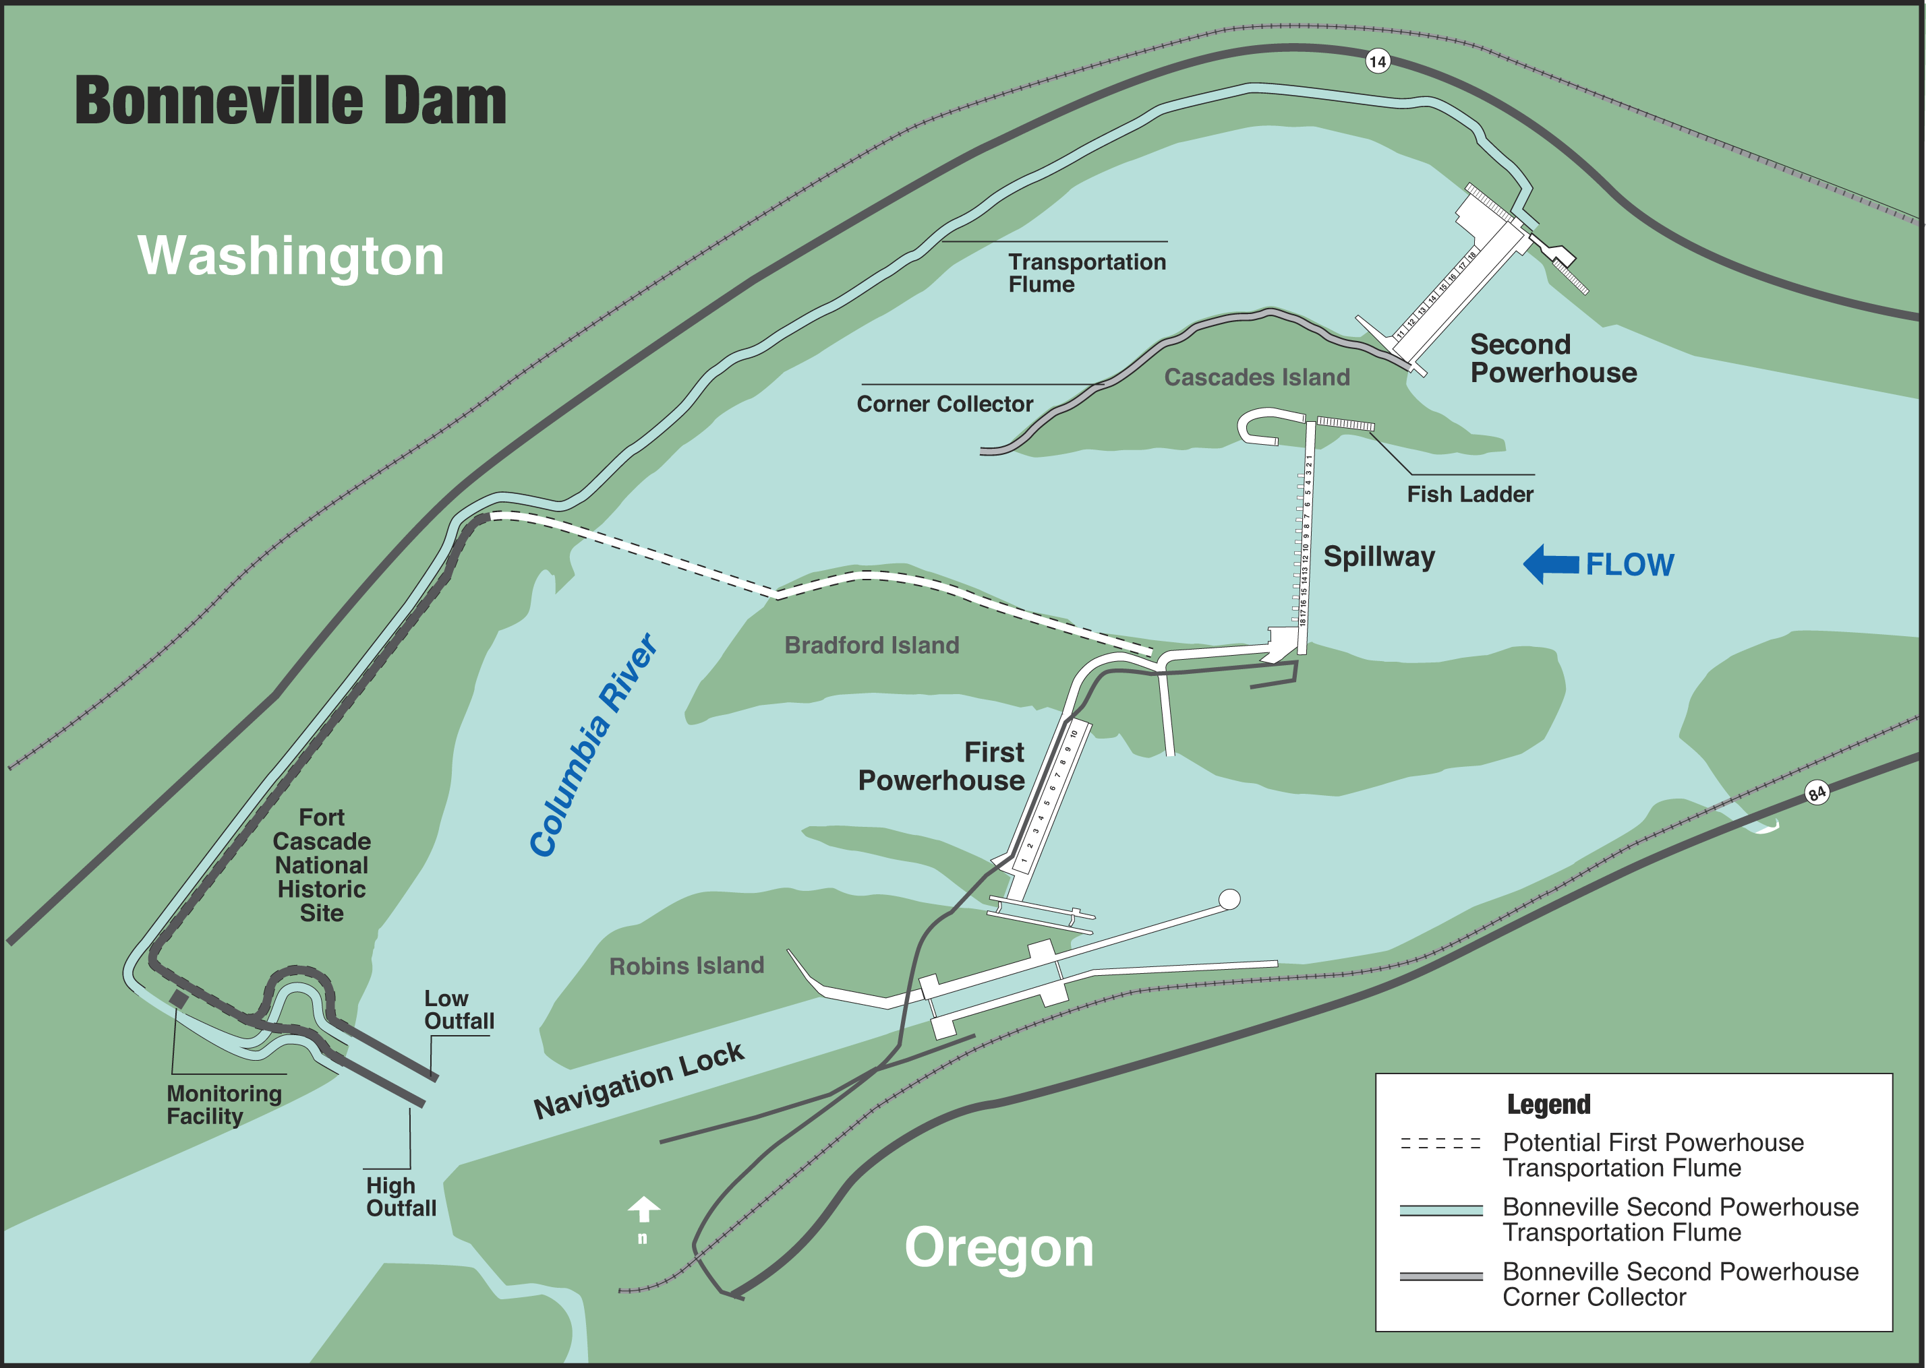
Figure 1 Bonneville Lock & Dam.

FISHWAY OPERATION AND ACTIVITIES
Fish Passage Plan (FPP) Violations
The results of 338 daily fishway inspections, 10 conducted by NOAA Fish or FPC, are shown in the following table. Project Fisheries and the control room operators conduct inspections each day. Shown are the FPP violations, numbers of days the violation occurred, and the percentage of days the item was in criteria. Items in criteria 100% of the time are not listed.
Table 1. Fish Passage Plan violations and percent in criteria.

The velocity meters were out of service or out of criteria most of the year. At PH1 the low velocities are due to an eddy in the slowest part of the collection channel. At PH2 the meter had been improperly installed. Proper installation is scheduled for the winter of 06/07.

B-Branch north entrance gate separated from its shaft in early July. Mechanics were unable to pull the gate due to tailwater elevations during the fish passage season. Repairs are scheduled for the 05/06 winter maintenance period. The south gate was used to compensate for the remainder of the fish passage season.
Cascades Island diffuser FG6-12 had a bent shaft in the spring. Due to the dewatering schedule, the diffuser is not scheduled to be repaired until the 06/07 winter maintenance period. FG6-11 is used to compensate when appropriate.

Weir 37 was out of criteria during early spring, late summer, and the fall. Water levels were over and under FPP criteria, usually no more than a couple tenths of a foot. AFF operations, fish (usually shad) blocking the weir drain, and increased aquatic debris loads were the primary causes for being out of criteria. Riggers and operators attempted to clean the trashrack whenever levels were more than .1’ out of criteria.

STS/VBS Inspections
The FPP requires submersible traveling screen (STS) inspections be conducted monthly and vertical barrier screen (VBS) inspections once every two months. Each STS has a timer that automatically shows elapsed time of operation, allowing STS inspection frequency to be measured by run time. The equivalent of one month of continuous operating time is 720 hours. Bonneville inspects both STS and VBS with an underwater video camera. Video allows STSs and VBSs to be inspected simultaneously, and eliminates the need to dip gatewells or handle fish.

Table 2. STS and VBS Inspections 2004-2005

Auxiliary Water System (AWS) Closures
The AWSs were closed on several occasions for various reasons during the 2004-2005 reporting year. AWS valves were closed during trashrack cleaning and usually cleaned multiple times each month with more frequent cleanings during fall and winter. ROV fishway inspections and HSS inspections resulted in AWS closures. AWSs were closed in response to oil discharges upstream of the dam. Table 3 shows the number of closures and average closure time per fish valve during each event.

Fish Valves | Reason for closure | Number of closures | Average closure time
FV 1-1 | Trashrack cleaning | 45 | 3 hours 11 minutes
FV 3-7 | Trashrack cleaning | 20 | 2 hours 25 minutes
FV 3-9 | Trashrack cleaning | 48 | 1 hour 35 minutes
FV 4-3 | Trashrack cleaning | 1 | 2 hours 56 minutes
FV 4-4 | Trashrack cleaning | 1 | 2 hours 56 minutes
FV 5-4 | Trashrack cleaning | 1 | 1 hour 36 minutes
FV 5-9 | Trashrack cleaning | 9 | 14 minutes
FV 6-9 | Trashrack cleaning | 4 | 11 minutes
FV 1-1 | ROV | 2 | 1 hour 44 minutes
FV 3-7 | ROV | 2 | 1 hour 51 minutes
FV 3-9 | ROV | 2 | 3 hours 4 minutes
FV 4-3 | ROV | 2 | 1 hour 8 minutes
FV 4-4 | ROV | 2 | 1 hour 8 minutes
FV 5-3 | ROV | 2 | 1 hour 20 minutes
FV 5-4 | ROV | 2 | 1 hour 20 minutes
FV 5-9 | ROV | 2 | 1 hour 20 minutes
FV 6-9 | ROV | 1 | 7 hours
FV 4-3 | HSS Inspections | 1 | 4 hours 20 minutes
FV 4-4 | HSS Inspections | 1 | 4 hours 20 minutes
FV 5-3 | HSS Inspections | 1 | 3 hours 45 minutes
FV 5-4 | HSS Inspections | 1 | 3 hours 45 minutes
FV 1-1 | Oil response | 1 | 1 hour 19 minutes
FV 3-7 | Oil response | 2 | 3 hours 22 minutes
FV 3-9 | Oil response | 2 | 3 hours 22 minutes
FV 4-3 | Oil response | 1 | 1 hour 19 minutes
FV 4-4 | Oil response | 1 | 1 hour 19 minutes
FV 5-3 | Oil response | 1 | 1 hour 19 minutes
FV 5-4 | Oil response | 1 | 1 hour 19 minutes
FV 5-9 | Oil response | 1 | 1 hour 19 minutes
FV 6-9 | Oil response | 1 | 1 hour 19 minutes
Table 3. Fish Valve Closures and Average Closure Time

Fish counts
WDFW undertakes the fish counting for all fish passing by the Washington Shore and Bradford Island fishways. From March until November, there are fish counters visually counting fish for 16 hours. From November until March, counts are video taped for 16 hours. The following chart gives an idea of our passage numbers and peak passage times.

Table 4. Fish passage at Bonneville Dam for 2005.

Zebra Mussels
Through weekly inspections of the monitoring station at the First Powerhouse and of all dewatered fishways, we have found no indication of zebra mussel colonization. It is understood that their arrival is inevitable. We continue monitoring with hopes that control programs can be initiated at the first indication of the zebra mussel’s arrival in the Pacific Northwest.

Avian Abatement Measures
Avian lines are strung at PH1 tailrace, spillway tailrace, PH2 tailrace, and over the B2 corner collector plunge pool. All lines were intact during the fish passage season. Hazing activities on piscivorous birds were conducted from 21 March through 22 July by USDA-APHIS-WS. Non-lethal hazing techniques included 15 mm screamer shells, cracker shells, and rockets.

Adult Fishway Temperature Monitoring
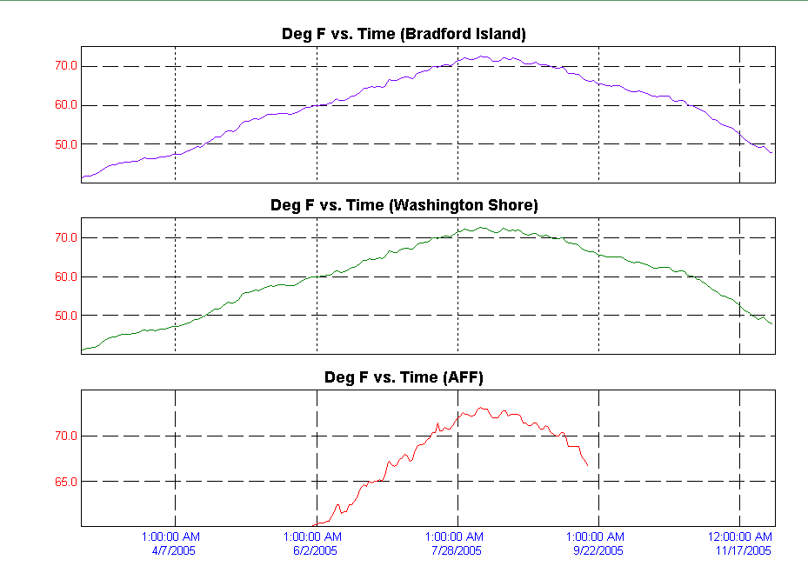
Project biologists monitor fishway temperatures throughout the fish passage season and the AFF primarily during the summer months. The following temperature charts illustrate temperature trends throughout the fish passage season. Detailed daily temperatures may be found in our weekly reports.
Table 5. Average Temperature in the Bradford Island fishway.
Table 6. Average Temperature in the Washington Shore fishway.
Table 7. Maximum Temperature in the Adult Fish Facility.

FISH FACILITY AND TURBINE OUTAGES
Fish Facility | Date Out | Date In | Reason for Outage
AFF | 24 Nov 2004 | 05 Apr 2005 | Winter Maintenance
Washington Shore | 27 Nov 2004 | 28 Feb 2005 | Winter Maintenance
UMT | 29 Nov 2004 | 28 Feb 2005 | Winter Maintenance
DSM1 | 15 Dec 2004 | 15 Sep 2005 | Closed until adult fallback season.
DSM2 | 20 Dec 2004 | 21 Feb 2005 | Winter Maintenance
B2 Corner Collector | 31 Aug 2004 | 03 Mar 2005 | Winter Maintenance
B2 Corner Collector | 05 Mar 2005 | 15 Apr 2005 | Closed until 2005 spill season
Cascades Island exit | 07 Mar 2005 | 31 Oct 2005 | Closed until VBS mods start in Nov 2005.
PH1 ITS | 04 May 2005 | 04 May 2005 | DIDSON barge installation
AFF | 20 Jul 2005 | 20 Jul 2005 | Water level sensor repairs
PH1 ITS | 11 Aug 2005 | 11 Aug 2005 | DIDSON barge removal
B2 Corner Collector | 31 Aug 2005 | Present | Closed until 2006 spill season
PH1 ITS | 26 Sep 2005 | 26 Sep 2005 | Oil response
DSM1 | 26 Sep 2005 | 26 Sep 2005 | Oil response
PH1 ITS | 08 Oct 2005 | 08 Oct 2005 | Oil response
DSM1 | 08 Oct 2005 | 08 Oct 2005 | Oil response
Washington Shore | 08 Oct 2005 | 08 Oct 2005 | Oil response
Bradford Island | 08 Oct 2005 | 08 Oct 2005 | Oil response
Cascades Island | 08 Oct 2005 | 08 Oct 2005 | Oil response
UMT | 31 Oct 2005 | Present | Winter Maintenance
Table 8. Fish Facility Outages & Maintenance

Fish Unit Outages and Reduced Loads
27 Nov 04 – 01 Mar 05 F1 OOS for winter maintenance at Washington shore.
21 Mar 05 – 21 Mar 05 F1 OOS due to governor trouble.
07 Apr 05 – 07 Apr 05 F1 OOS due to loss of governor control.
31 May 05 – 31 May 05 F1 OOS due to a gland water leak.
11 Jul 05 – 11 Jul 05 F1 OOS due to governor lock up.
11 Jul 05 – 12 Jul 05 F1 OOS due to loss of governor control.
02 Aug 05 – 02 Aug 05 F1 OOS for PH2 PCC ROV inspection and slip ring maintenance.
08 Aug 05 – 09 Aug 05 F1 OOS due to low governor oil pressure.
22 Sep 05 – 22 Sep 05 F1 OOS due to a relay trip.
21 Oct 05 – 21 Oct 05 F1 OOS for switching activities.
18 Nov 05 – 18 Nov 05 F1 Reduced load to facilitate trashrack raking.
19 Nov 05 – 19 Nov 05 F1 Speed no load to float trash and facilitate trashrack raking.
19 Nov 05 – 19 Nov 05 F1 OOS for trashrack raking.
19 Nov 05 – 19 Nov 05 F1 Reduced load for trashrack raking.
19 Nov 05 – 20 Nov 05 F1 OOS to float trash.
21 Nov 05 – 21 Nov 05 F1 Reduced load for trashrack raking.
22 Nov 05 – 23 Nov 05 F1 OOS due to breaker failure.
25 Nov 05 – 25 Nov 05 F1 Reduced load for trashrack raking.
27 Nov 05 – 27 Nov 05 F1 Reduced load for trashrack raking.
27 Nov 05 – 27 Nov 05 F1 Reduced load for trashrack raking.
27 Nov 05 – 27 Nov 05 F1 Reduced load for trashrack raking.

27 Nov 04 – 28 Feb 05 F2 OOS for winter maintenance at Washington shore.
10 Mar 05 – 10 Mar 05 F2 On standby to facilitate operator training activities.
08 Jul 05 – 09 Jul 05 F2 OOS due to loss of line protection.
09 Jul 05 – 09 Jul 05 F2 OOS for ZJ switching.
17 Jul 05 – 17 Jul 05 F2 OOS due to a transformer outage.
26 Jul 05 – 27 Jul 05 F2 OOS due to a T12 outage.
28 Jul 05 – 28 Jul 05 F2 in standby for switching.
02 Aug 05 – 02 Aug 05 F2 OOS for PH2 PCC ROV inspection and slip ring maintenance.
18 Nov 05 – 18 Nov 05 F2 OOS fro trashrack raking.
19 Nov 05 – 19 Nov 05 F2 Speed no load to float trash and facilitate trashrack raking.
19 Nov 05 – 19 Nov 05 F2 OOS for trashrack raking.
19 Nov 05 – 19 Nov 05 F2 Reduced load to facilitate raking.
19 Nov 05 – 20 Nov 05 F2 OOS to float trash.
21 Nov 05 – 21 Nov 05 F2 Reduced load for trashrack raking.
22 Nov 05 – 22 Nov 05 F2 OOS for trashrack raking.
23 Nov 05 – 23 Nov 05 F2 Reduced load to float trash and facilitate trashrack raking.
25 Nov 05 – 25 Nov 05 F2 Reduced load for trashrack raking.
27 Nov 05 – 27 Nov 05 F2 Reduced load for trashrack raking.
27 Nov 05 – 27 Nov 05 F2 Reduced load for trashrack raking.
27 Nov 05 – 27 Nov 05 F2 Reduced load for trashrack raking.

Fish units 1 and 2 were placed on standby at other times during the year to “float” trash away from the trash racks. When drawdown measured one foot or greater, fish units were shut down. An adjacent unit was then operated to pull trash away from the fish unit trashracks. This procedure helped prevent debris and silt from accumulating in front of the fish units. Most of the unit outages associated with the floating of trash and debris occurred between midnight and 0300 to minimize impact on adult fish passage.

Turbine Unit | Date Out | Date In | Reason for Outage
0 | 29 Jul 04 |  | Five year overhaul
10 | 24 Aug 04 | 14 Nov 05 | Gantry 3 construction
2 | 12 Oct 04 |  | Turbine rehab
11 | 15 Nov 04 | 31 Jan 05 | Overhaul
18 | 10 Jan 05 | 13 Jan 05 | Unknown
17 | 24 Jan 05 | 26 Jan 05 | New annunciator
12 | 31 Jan 05 | 02 Feb 05 | Bulkhead modifications
14 | 07 Feb 05 | 10 Feb 05 | Breaker modifications
16 | 10 Feb 05 | 11 Feb 05 | Breaker modifications
13 | 14 Feb 05 | 15 Feb 05 | Breaker modifications
15 | 16 Feb 05 | 17 Feb 05 | Breaker modifications
1 | 24 Mar 05 | 25 Mar 05 | Acceptance testing
8 | 04 Apr 05 | 06 Apr 05 | Gantry Crane testing
15 | 11 Apr 05 | 14 Apr 05 | Distribution valve work
9 | 18 Apr 05 | 29 Apr 05 | XJ2.1 work and Gantry 3
14 | 25 Apr 05 | 27 Apr 05 | Brake air cylinder repair
9 | 30 Apr 05 | 02 May 05 | Jacking
16 | 12 May 05 | 16 May 05 | Breaker failure
15 | 20 May 05 | 21 May 05 | STS failure
9 | 31 May 05 | 01 Jun 05 | Semi-annual maintenance
7 | 13 Jun 05 | 16 Jun 05 | Semi-annual maintenance
8 | 13 Jun 05 | 15 Jun 05 | Semi-annual maintenance
3 | 20 Jun 05 | 23 Jun 05 | Transformer maintenance
4 | 20 Jun 05 | 23 Jun 05 | Transformer maintenance
1 | 27 Jun 05 | 30 Jun 05 | Bank 1&2 outage
16 | 08 Jul 05 | 14 Jul 05 | Governor control work
5 | 11 Jul 05 | 14 Jul 05 | Annual and bank 5/6 biannual maintenance
6 | 11 Jul 05 | 14 Jul 05 | Bank 5/6 biannual maintenance
1 | 18 Jul 05 | 21 Jul 05 | Turning slip rings
4 | 18 Jul 05 | 25 Aug 05 | Five year overhaul
13 | 18 Jul 05 | 29 Jul 05 | Headgate HSS inspections
3 | 19 Jul 05 | 21 Jul 05 | Gantry crane rail work
5 | 19 Jul 05 | 21 Jul 05 | Gantry crane rail work
6 | 19 Jul 05 | 21 Jul 05 | Gantry crane rail work
7 | 19 Jul 05 | 21 Jul 05 | Gantry crane rail work
8 | 19 Jul 05 | 21 Jul 05 | Gantry crane rail work
9 | 19 Jul 05 | 21 Jul 05 | Gantry crane rail work
15 | 26 Jul 05 | 28 Jul 05 | T12 outage
16 | 26 Jul 05 | 28 Jul 05 | T12 outage
17 | 26 Jul 05 | 28 Jul 05 | T12 outage
18 | 26 Jul 05 | 28 Jul 05 | T12 outage
14 | 01 Aug 05 | 12 Aug 05 | Headgate HSS inspections
15 | 15 Aug 05 | 19 Sep 05 | Circuit breaker repair/annual maintenance
16 | 15 Aug 05 | 20 Sep 05 | Circuit breaker repair/annual maintenance
17 | 15 Aug 05 | 19 Aug 05 | Circuit breaker repair/annual maintenance
18 | 15 Aug 05 | 19 Aug 05 | Circuit breaker repair/annual maintenance
3 | 29 Aug 05 | 30 Aug 05 | Transformer failure
4 | 29 Aug 05 | 30 Aug 05 | Transformer failure
6 | 29 Aug 05 | 21 Nov 05 | Five year overhaul
11 | 01 Sep 05 |  | Rotor failure
17 | 19 Sep 05 | 12 Oct 05 | Circuit breaker repair/T-12 maintenance
18 | 19 Sep 05 | 13 Oct 05 | Circuit breaker repair/T-12 maintenance
16 | 11 Oct 05 | 13 Oct 05 | T/12 outage
12 | 13 Oct 05 | 04 Nov 05 | Main Unit Breaker replacement
13 | 01 Nov 05 |  | FGE/ Four year overhaul
14 | 03 Nov 05 |  | Main Unit Breaker replacement
10 | 15 Nov 05 |  | Turbine rehab
17 | 19 Nov 05 | 20 Nov 05 | VBS cleaning
Table 9. Turbine Outages of at least 24 hours

Fish Removal
Fish passage facilities and turbine units are taken out of service and dewatered for inspection, preventative maintenance, repairs, and modifications. As facilities and turbine units are dewatered, project biologists, outside agency personnel, and other project personnel follow the fish recovery plans to minimize impacts on fish. Adult salmonids and lamprey are released into the forebay at the new navlock; sturgeon and juvenile salmonids are released below the dam at Hamilton Island.
The following is a summary of the number of fish removed during dewaterings. All fish were recovered in good condition unless otherwise noted.
South Monolith (12-14-2004): Two juvenile chinook, four peamouth, three northern pikeminnow.

DSM1 (12-15-2004): Three juvenile shad, one juvenile unclipped steelhead, one juvenile chinook.

Unit 4 draft tube (07-19-2005): Two dead sturgeon (24” each), two live sturgeon (24-36” each), two adult lamprey, two clipped juvenile steelhead, one channel catfish, one sculpin.

AFF exit ladder (07-20-2005): one adult unclipped sea-run cutthroat.

Unit 14 gatewells (08-01-2005): 12 subyearling chinook.

Unit 4 tail logs (08-19-2005): one sturgeon and three sculpin.

Unit 6 draft tube (08-29-2005): One live sturgeon, one live lamprey, one live channel catfish.

Unit 11 draft tube (09-20-2005): 30 live sturgeon, six catfish, one peamouth.

Unit 6 tail logs (10-31-2005): three sturgeon, three bluegill, and ten sculpin.

UMT (11-02-2005): one juvenile steelhead, one adult steelhead, one rainbow, one chinook jack, one carp, two northern pikeminnow, two peamouth, 50-75 juvenile shad.

Unit 13 draft tube (11-02-2005): nine catfish, 12 sturgeon.

Unit 10 draft tube (11-16-2005): five catfish, four sturgeon.
GLOSSARY
AFF----- Adult Fish Facility. Lab associated with the Washington Shore ladder. Adult fish are trapped for research purposes.
AWS-------------------------Auxiliary Water Supply.
B2CC---- Powerhouse Two Corner Collector. A surface bypass system located in the southern corner of the Bonneville Second Powerhouse forebay.
BiOp Biological Opinion.
BON Bonneville Lock & Dam.
Downwell Opening through which water and fish drop after excess water is drawn away through a dewatering screen. Start of the transport conduit for fish from DSM1 to the tailrace.
DSM 1-- Downstream Migrant transportation channel (PH1). Transport channel for juvenile fish from gatewell orifices to the downwell.
DSM 2-- Downstream Migrant transportation channel (PH2). Transport channel for juvenile fish from gatewell orifices to the juvenile transport pipe.
CRITFC Columbia River Intertribal Fish Commission.
FFU----- Fisheries Field Unit. Unit in the Corps of Engineers’ Portland District Construction, Operations Division that conducts fish related evaluations and monitoring.
Forebay That area of a reservoir immediately upstream of a dam.
FPC Fish Passage Center.
FPP Fish Passage Plan.
HSS--------------------------Hydraulic Steel Structures.
ITS Ice and Trash Sluiceway.
JBS Juvenile Fish Bypass System.
Kcfs Thousand cubic feet per second.
NDE----- North Downstream Entrance. Refers to one of the four large overflow weir adult fishway entrances at PH2.
NUE North Upstream Entrance. See NDE.
NOAA Fish National Oceanic and Atmospheric Administration Fisheries (NMFS).
ODFW Oregon Department of Fish & Wildlife
OOS Out Of Service.
PCC----- Powerhouse Collection Channel. Part of the adult fishway spanning the length of the downstream side of each powerhouse.
PH1 Bonneville First Powerhouse.
PH2 Bonneville Second Powerhouse.
PIT ------ Passive Integrated Transponder. A tag inserted into juvenile and adult fish. Detectors are installed at all fish passage systems.
Project Bonneville Lock & Dam.
ROV--------------------------Remotely Operated Vehicle.
SDE South Downstream Entrance. See NDE.
SMF Smolt Monitoring Facility. Lab associated with the PH2 JBS.
SUE South Upstream Entrance. See NDE.
STS Submersible Traveling Screen.
Tailwater The portion of a river immediately downstream of a dam or powerhouse.
TIES Turbine Intake Extension Screen.
Tule Early spawning fall chinook.
UMT----- Upstream Migrant Transportation channel. Connects Cascades Island ladder to Washington Shore ladder through PH2.
VBS Vertical Barrier Screen.
WDFW Washington Department of Fish & Wildlife.

REFERENCES
2004. Fish Passage Plan for Corps of Engineers Projects. U. S. Army Corps of Engineers, North
Pacific Division, Portland, Oregon.

2005. Fish Passage Plan for Corps of Engineers Projects. U. S. Army Corps of Engineers, North
Pacific Division, Portland, Oregon.

